Project 3: Measuring Wireless Throughput Capacity

# **Project Setup**

The wireless LAN nodes are arranged in a 1000m x 1000m size square grid using a random allocator. The OnOffApplication is used in order to send UDP packets between pairs of randomly allocated nodes and the specified parameters are varied in order to measure the throughput capacity of each node. We varied the number of nodes, traffic intensity, routing protocol (AODV, OLSR) used and the transmission power (PTx) of each node.

In our experiment, we decided to use the IEEE 802.11g standard for the running nodes, and used a channel data rate of 6 Mbps and data rate for the control packets were also 6 Mbps. We wanted to figure out which configuration would give the maximum throughput capacity if we really pushed bar high and set the source data rate to 54 Mbps, which is distributed amongst all the nodes. This rate was also subject to a duty cycle of 0.5 which was set at the nodes using a source with a constant random variable. The nodes were allocated in the square grid, using the RandomRectanglePositionAllocator, using a uniform random variable ranging from 0 to 1000.0.

We create the physical layer channel using the YansWifiChannelHelper and physical layer helper and set the transmit power appropriately. Then we invoke the WiFi MAC helper which operates without a QOS function. The routing algorithm to be used is chosen according to the input provided.

The total number of transmitted bytes was calculated using a callback function that latched on to the trace attribute that would trigger a callback every time a packet was sent. Therefore, we counted the number of packets sent by counting the number of times the callback was triggered, and later multiplied by the packet size (1500 bytes) (IEEE 802.11g standard) , to get the total number of transmitted bytes.

The source and destination nodes were randomly assigned using a random allocation function that we designed, which allocates a source node to transmit to a destination node. The total number of received and transmitted bytes are counted, and the efficiency is calculated.

The following trends were observed after multiple runs for each of the cases mentioned, and we chose the one which gave us the most consistent results.

# Effects of Routing Protocol on Efficiency

The routing protocols AODV (Adhoc On-demand Distance Vector) and OLSR (Optimized Link State Routing) protocol are intrinsically different in the way they populate the routing tables.

AODV operates in a mechanism such that routes are obtained by the exchange of routes with directly connected neighbors. OLSR on the other hand maintains global state by transmitting link state information to all the other nodes of the network. Since **OLSR** **transmits a lot of packets, congestion might occur in the cases where the number of nodes are high**.

AODV performs poorly in the case where **the network is very volatile and there are many broken links**, because re-computing routes in AODV takes a lot of time. OLSR on the other hand is much more flexible in a volatile network, as it uses the link state mechanism and floods the entire network and fixes the broken links faster.

* In the case of AODV, the convergence (convergence is a state where all the routes in the network are mapped and known to the nodes) takes a long time compared to link state. Therefore OLSR converges faster and hence more bytes are transmitted and better efficiency is obtained in the case of OLSR.
* AODV consumes more share of the bandwidth, as it sends periodic updates of the routing tables, while OLSR only sends triggered updates when changes in the routes occur.
* At **lower transmit powers**, AODV shows better performance in some cases compared to OLSR, this is due to the fact that **AODV needs to communicate only with its directly connected neighbors but on the other hand OLSR needs to communicate with the entire network**, which leads to a lower efficiency.

# Effects of Node Density on Efficiency

In our simulation, we considered a 1000 m2 square grid, initially populated with 20 nodes and 100 nodes, which offers a node density of one node in an area of 250 m2 and one node in an area of 100 m2.

* As a result, the network performance was very poor, and this resulted in almost zero efficiency for lower powers like 1mW and 10 mW. This was expected, since our channel rate was pretty low and the nodes were transmitting at a very high source rate.
* As the node density was increased, the transmission efficiency increased considerably for 500 nodes, because the node density increases to 1 node in a 2 m2 area. This increases the ability of the nodes to find nodes through which it can forward traffic, and hence a lot of the packets get delivered.
* For 1000 nodes, the node density is a node per square meter, so in this case the probability that collisions can happen is high, and hence the efficiency decreases.

**Note:**

We observed a **perfect zero efficiency for lower transmission powers when the number of nodes are also low**, this is because of the extremely low node density. At powers such that 1 mW and 10 mW, the transmitted packets would not even be able to reach its immediate neighbors. However, for the same number of nodes at higher transmission powers a very low efficiency was observed.

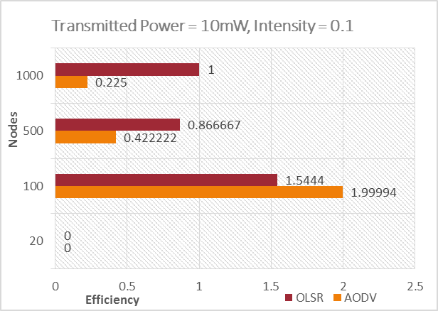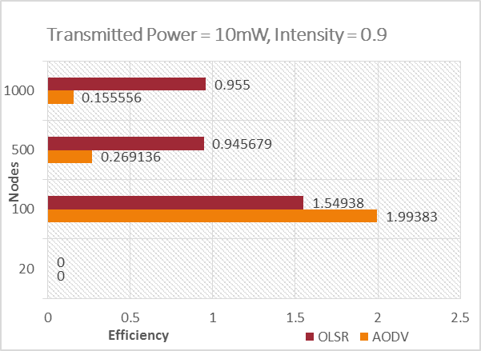

For low powers, when the traffic intensity is increased from 0.1 to 0.9, efficiency decreases for higher number of nodes. For a lower number of nodes, around 100, the efficiency remains unchanged. Also, we observe on average OLSR performs better when there is a higher number of nodes, since the network is more volatile.

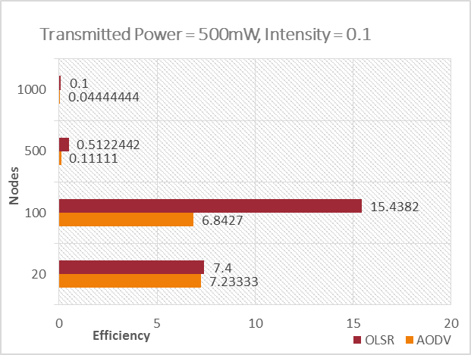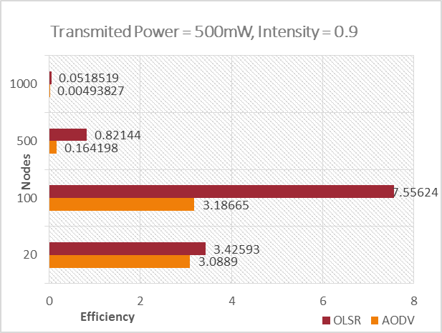

For higher transmit powers, when the traffic intensity is increased from 0.1 to 0.9, efficiency decreases for higher number of nodes. We can see that OLSR clearly performs better than AODV for various reasons mentioned above. The efficiency in general decreases as the number of nodes increases because of interference.

# Effects of Transmit Power on Efficiency

The amount of transmission power required increases with the distance between the nodes, and if **the power is too low then the packets will be dropped** as they won’t be detected. Lower node densities performed better with increased transmission power because of lesser interference and if the node intensity is high, the nodes will have to backoff a lot before they can transmit.

* We can clearly observe that when the transmission power is too low, i.e. in the 1 mW and 10 mW case, the efficiency is really low and the received bytes are very less because of lots of packets being dropped.
* When the transmit power is increased to 100 mW and the number of nodes is low, i.e. 20 or 100, the efficiency greatly increases. The efficiency is maximum for the 100 nodes case with 100 mW, and if the number of nodes are increased further to 500 and 1000, the efficiency drops due to collisions.
* When the transmit power is increased to 500 mW, then the efficiency is maximum in the 100 node OLSR case, and the same trend as in 100 mW is observed. As the number of nodes increases, the efficiency initially increases to a maximum and then decreases.

# Effects of Traffic Intensity on Efficiency

Traffic Intensity is the total demand on the network which is divided by the theoretical maximum possible data rate. The traffic intensity affects the efficiency of the network, as the intensity increases the efficiency decreases, in almost all the cases.

* For low traffic intensities, in the 500 mW case, the maximum efficiency is obtained. For a higher number of nodes, the network capacity reaches maximum and hence, the efficiency falls.
* In the case of high traffic intensities, since our simulation suffers from very high losses, the network is constrained with a low channel bandwidth of 6 Mbps, and high a source transmission rate we observe that high intensities perform poorly.
* In the cases with lower powers and lower number of nodes, the efficiency increases slightly with traffic intensity, because the goodput increases since the interference in these cases is low.

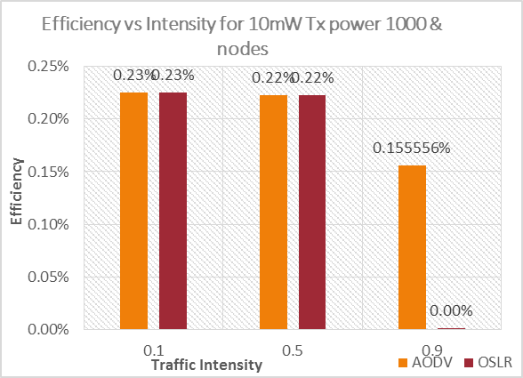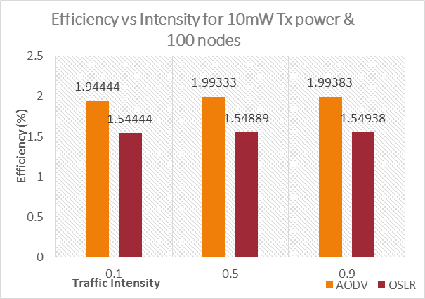

At lower powers, when the number of nodes increases, and as the traffic intensity is increased, the efficiency decreases. This is due to the fact that there are more bytes injected into the network which causes congestion, and leads to a lot of packets being dropped.

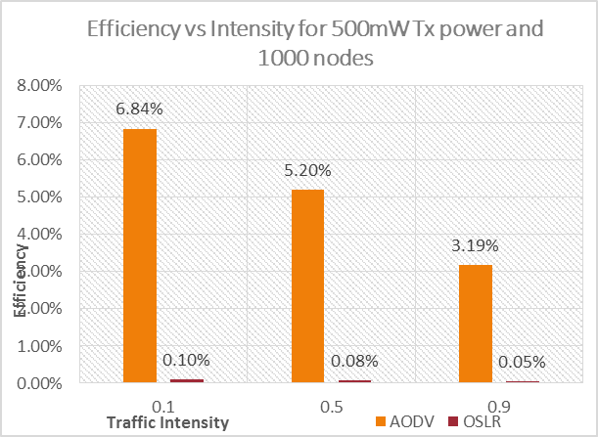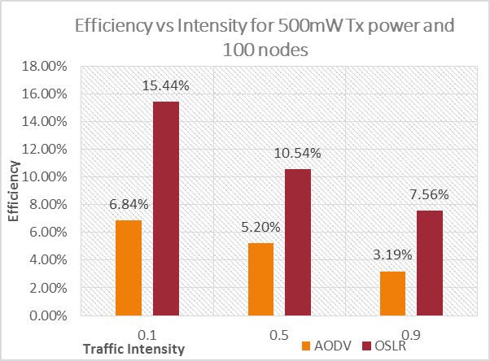

The efficiency is maximum for the case where the traffic intensity is low and the number of nodes are lower, and the transmitted power is the highest. This is probably due to the most optimal node density, a high transmission power and the network capacity is being utilized the best in this case. As the number of nodes increases, the efficiency decreases greatly, this is again because of congestion.

# Conclusion

In this simulation we observed that there are numerous variables which govern the performance of wireless ad-hoc networks. We cannot pin point an exact optimal combination of these variables, which are guaranteed to yield maximum wireless throughput capacity.

The Traffic Intensity was also a crucial factor which controlled the overall throughput capacity of the network, when higher intensities are combined with higher number of nodes, the performance decreases due to congestion, while lower intensities on average provided better efficiencies compared to higher intensities.

We find that better utilization is observed for an optimal number of nodes (100) and at higher transmission powers. The protocols AODV and OLSR both performed well in certain cases, although on an average OLSR did perform slightly better than AODV, which was also observed in the case where we observed maximum efficiency.